DRAFT

Soil temperature
Mette Lægdsmand, 2007.

The temperature is calculated using a finite difference solution as proposed by Hansen, et al. 1990 with minor changes. The upper boundary temperature is the air temperature if no snow is present. If snow is present the surface temperature is calculated using an assumption of steady state heat flow through the snow pack and the upper soil layer. The temperature model runs with 5 min time steps if there is freezing and thawing anywhere in the profile and otherwise with one hour time steps.

One dimensional heat flow due to conduction and convection (q_{h}) is given by
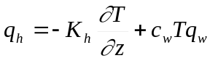 [1]
where K_{h} is the heat conductivity of the soil, T is temperature, z is depth, c_{w} is the specific heat capacity of liquid water and q_{w} is the flow of water.

The conservation of heat gives
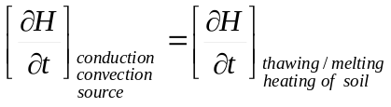 [2]
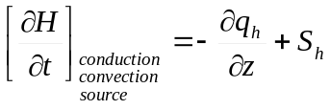 [3]
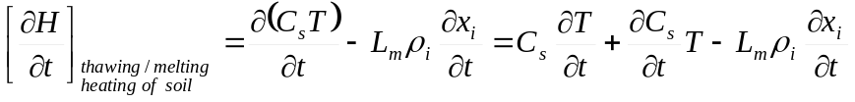 [4]
where H is the heat content, t is time, S_{h} is the source of heat (negative if sink), C_{s} is the heat capacity of the soil, L_{m} is the latent heat of melting, ρ_{i} is the density of ice, and x_{i} is the volumetric ice content.

Assuming that the change in air content does not influence the change in heat capacity of the soil it can be expressed as:
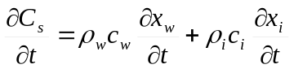 [5]
where ρ_{w} is the density of liquid water and c_{i} is the specific heat capacity of ice.

Since water can be present as both ice and water
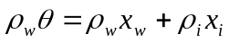 [6]
where θ is the total volumetric water content and x_{w} is the volumetric content of liquid water.

Differentiation of [6] gives
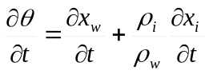 [7]

Conservation of water gives
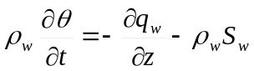 [8]
where S_{w} is the water source.

Combining [7] and [8] gives
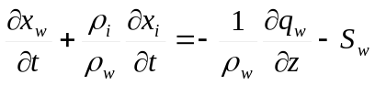 [9]

Combining equation [4], [5] and [9] gives
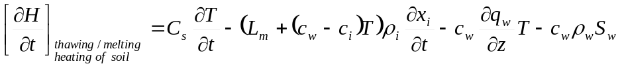 [10]
During freezing or thawing L_{m}>> (c_{w}-c_{i})T and otherwise 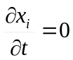:
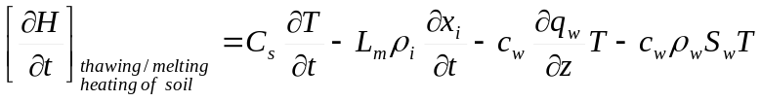 [11]
We assume that the only sink in the system is when water is removed from the soil (by plant uptake or evaporation) and that it can be described by 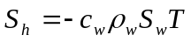. Combination of eq. [1], [2] and [11] gives
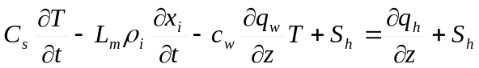 [12]

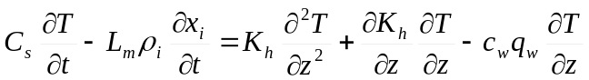 [13]

Eq. [13] reduces to the governing equation for soil temperature when no freezing or thawing takes place 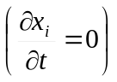.
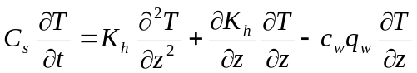 [14]

When freezing and thawing takes place we assume that the temperature in the soil can be described by eq. [15] as proposed by Miller (1980)
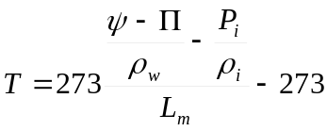 [15]
where ψ is the pressure potential of the soil, Π is the osmotic pressure and Pi is the pressure of ice. Assuming that the osmotic potential and the pressure of ice are constant we obtain by differentiation:
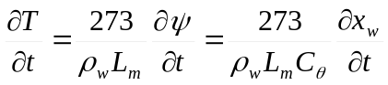 [16]
C_{θ} is the specific water capacity of the soil calculated from retention data in [(m WC)⁻¹] and should be multiplied by 1.0919 10⁻⁵ m³ J⁻¹ mWC.

Combination of eq [7] and [16] gives
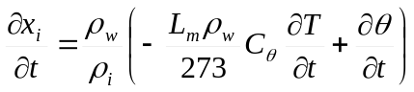 [17]
and then we combine this with eq. [8] and assume that S_{w} is zero during freezing and thawing we get:
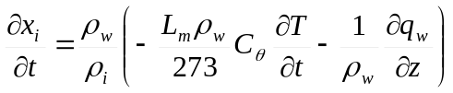 [18]
Eq. [18] gives the change in volumetric ice content during freezing and thawing.

The equation governing change in temperature during freezing and thawing is then
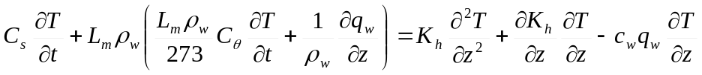 [19]
or
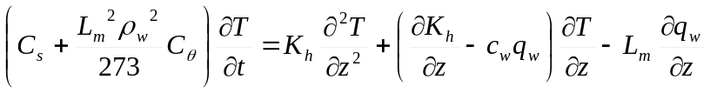 [20]

Lower boundary condition
The lower boundary condition is calculated neglecting frost, thaw and transfer of heat by convection and assuming a constant heat capacity and conductivity of the soil profile. The heat conduction equation is
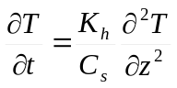 [21]
This is solved analytically with upper and lower boundary conditions:
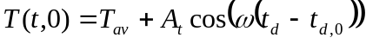 [22]
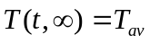 [23]
where T_{av} is the annual average air temperature, A_{t} is the amplitude of the daily average temperature, ω is 2π/265 day⁻¹, t_{d} is the day of the year and t_{d,0} is the day of the year with the highest temperature.

The solution for the end of the profile (z_{max}) is:
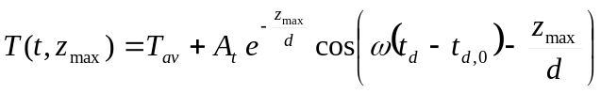 [24]
where d is damping depth.

The mean heat capacity and heat conductivity of the profile is calculated at pF 2 and with no frozen soil.

Upper boundary condition
If no snow is present the upper boundary condition is that the surface temperature equals the air temperature. If snow is present and the air temperature is above zero we assume that the snow contains liquid water and therefore the surface temperature is set to 0 ºC. If air temperature is below zero and snow is present we assume that the heat flow through the snowpack and the upper half of the first soil layer is at steady-state.

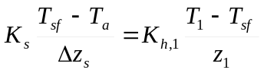 [25]

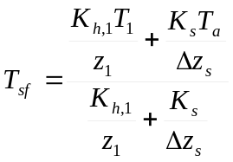 [26]

Heat conductivity and heat capacity of soil layer
The heat conductivity is calculated by an empirical relation from (kilde)
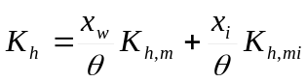 [27]
where
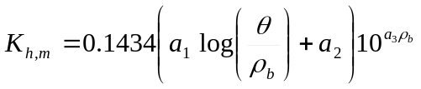 [28]
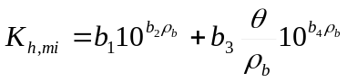 [29]
where the constants ai and bi are defined as
clay content | a₁ | a₂ | a₃ | b₁ | b₂ | b₃ | b₄
≤ 10 % | 0.700 | 0.400 | 0.625 | 0.00158 | 1.336 | 0.00375 | 0.9118
> 10 % | 0.700 | 0.400 | 0.625 | 0.00144 | 1.320 | 0.00360 | 0.8743

The heat capacity is calculated by
[30]
where x_{m} is the volumetric content of mineral particles, ρ_{m} is the density of mineral particles, c_{m} is the specific heat capacity of the mineral particles, x_{o} is the volumetric content of organic particles, ρ_{o} is the density of organic particles and c_{o} is the specific heat capacity of the organic particles.

Numerical solution
The cranck nicholsen finite difference method was used to calculate the numerical solution. The time and depth increment may vary during the simulation. Eq. [] and [] is approximated to

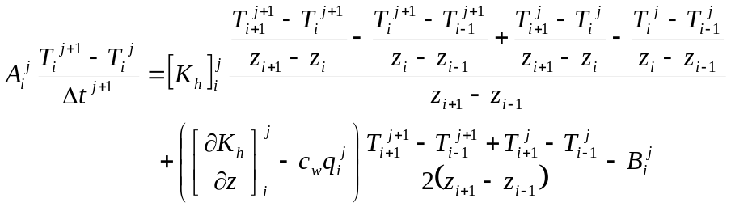 [31]

where i is index for depth and j is index for time and
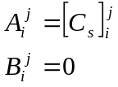 ; [32]
when no freezing or thawing takes place and
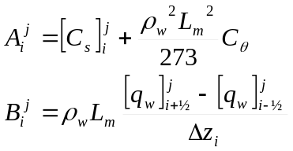; [33]
when freezing or thawing takes place. We can rearrange Eq. [31] to give

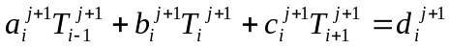 [34]
where
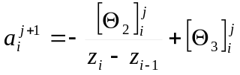

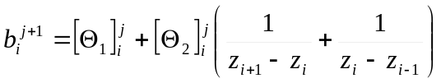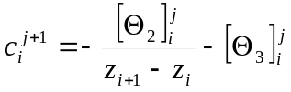
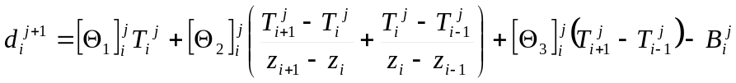
and
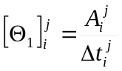

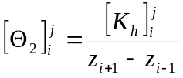
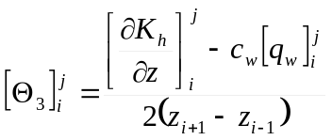

At the upper boundary surface temperature is used for T₋₁ and at the lower boundary the value calculated with the analytical solution is used for T_{n}. Mere om boundary……

The set of linear equations (eq. [34]) for the entire profile can be written as a matrix equation with a tridiagonal matrix M.

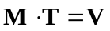
where

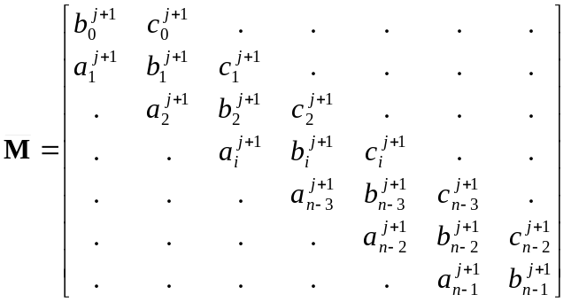; 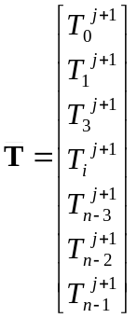 and 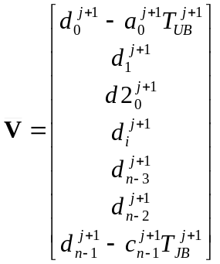

The tridiagonal matrix equation is solved using the double sweep method for each timestep and the consequent change in ice content is then calculated using an approximation of Eq. [18]:

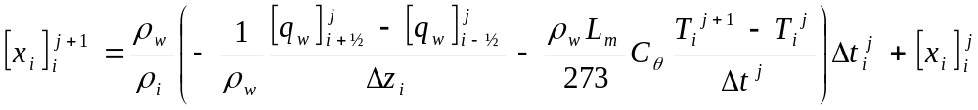

The solution anticipates that freezing and thawing progresses during an entire timestep. If thawing or freezing is initiated or stopped in a layer within a timestep we set the temperature of this layer to 0 ºC.

Parameters

A_{t} | Amplitude in air temperature | ºC
c_{i} | specific heat capacity of ice | J kg⁻¹ ºC ⁻¹
C_{s} | Volumetric heat capacity of bulk soil | J m⁻³ ºC ⁻¹
c_{m} | specific heat capacity of mineral particles | J kg⁻¹ ºC ⁻¹
c_{o} | specific heat capacity of organic particles | J kg⁻¹ ºC ⁻¹
c_{w} | specific heat capacity of liquid water | J kg⁻¹ ºC ⁻¹
C_{θ} | specific water capacity of the soil | J m⁻³
d | depth of damping | m
H | Heat content of soil | J m⁻²
K_{h} | thermal conductivity | W m⁻¹ ºC⁻¹
K_{s} | thermal conductivity of snow | W m⁻¹ ºC⁻¹
L_{m} | Latent heat of melting | J kg⁻¹
P_{i} | ice pressure | Pa
q_{h} | Heatflux | W m⁻²
q_{w} | water flow | m³m⁻²s⁻¹
S_{h} | Heat source | J m⁻²s⁻¹
S_{w} | volumetric water sink | m³m⁻³s⁻¹
T | temperature | ºC
t | time | s
T_{a} | Daily mean of air temperature | ºC
T_{av} | Annual average air temperature | ºC
t_{d} | day in year
t_{d,0} | day number for highest air temperature
T_{sf} | Surface temperature | ºC
x_{i} | Volumetric ice content | m³m⁻³
x_{m} | Volumetric content of mineral particles | m³m⁻³
x_{o} | Volumetric content of organic particles | m³m⁻³
x_{w} | Volumetric water content of liquid water | m³m⁻³
z | depth | m
z_{max} | Depth of end of profile | m
Δz_{s} | depth of snow pack | m
θ | Volumetric total water content | m³m⁻³
Π | osmotic potential | Pa
ρ_{i} | Density of ice | kg m⁻³
ρ_{m} | Density of mineral particles | kg m⁻³
ρ_{o} | Density of organic particles | kg m⁻³
ρ_{w} | Density of water | kg m⁻³
ψ | pressure potential | Pa
ω | conversion constant | d⁻¹

References
Hansen, S., Jensen, H.E., Nielsen, N.E. and Svendsen, H. 1990. DAISY – Soil plant atmosphere system model. NPo-forskning fra Miljøstyrelsen. Nr. A10.

Miller, R.D. 1980. Freezing phenomena in soils. In: Application of soil physics. Academic press.

SoilN kilde

